|  |  |  |
| --- | --- | --- |
| Deu_logo | **DOKUZ EYLUL UNIVERSITY**  **ENGINEERING FACULTY**  **DEPARTMENT OF COMPUTER ENGINEERING** | logo-en |

**CME1214 LOGIC DESIGN**

**PRELIMINARY REPORT**

**LAB 4**

**by**

**Mesut Selim Serbes**

**2017510100**

**Lecturers**

**Instructor Dr. Özlem Öztürk**

**Res.Asst. Dr. Feriştah Dalkılıç**

**Res.Asst. Özlem Yerlikaya**

**Res.Asst. Gökmen Katipoğlu**

**IZMIR**

**30.04.2019**

* + - 1. **TRUTH TABLE**

**1.Experiment**

|  |  |  |  |  |  |  |  |  |  |  |
| --- | --- | --- | --- | --- | --- | --- | --- | --- | --- | --- |
| **S2** | **S1** | **S0** | **A** | **B** | **C** | **D** | **E** | **F** | **G** | **H** |
| **0** | **0** | **0** | **a** | **1** | **1** | **1** | **1** | **1** | **1** | **1** |
| **0** | **0** | **1** | **1** | **b** | **1** | **1** | **1** | **1** | **1** | **1** |
| **0** | **1** | **0** | **1** | **1** | **c** | **1** | **1** | **1** | **1** | **1** |
| **0** | **1** | **1** | **1** | **1** | **1** | **d** | **1** | **1** | **1** | **1** |
| **1** | **0** | **0** | **1** | **1** | **1** | **1** | **e** | **1** | **1** | **1** |
| **1** | **0** | **1** | **1** | **1** | **1** | **1** | **1** | **f** | **1** | **1** |
| **1** | **1** | **0** | **1** | **1** | **1** | **1** | **1** | **1** | **g** | **1** |
| **1** | **1** | **1** | **1** | **1** | **1** | **1** | **1** | **1** | **1** | **h** |

**2.Experiment**

**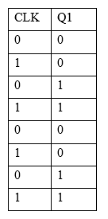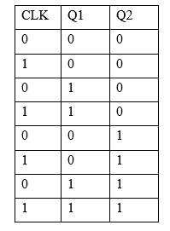a.1 a.2**

**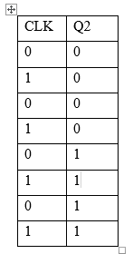**

**b.1 b.2**

* + - 1. **LOGIC DIAGRAM**

**1.Experiment**

**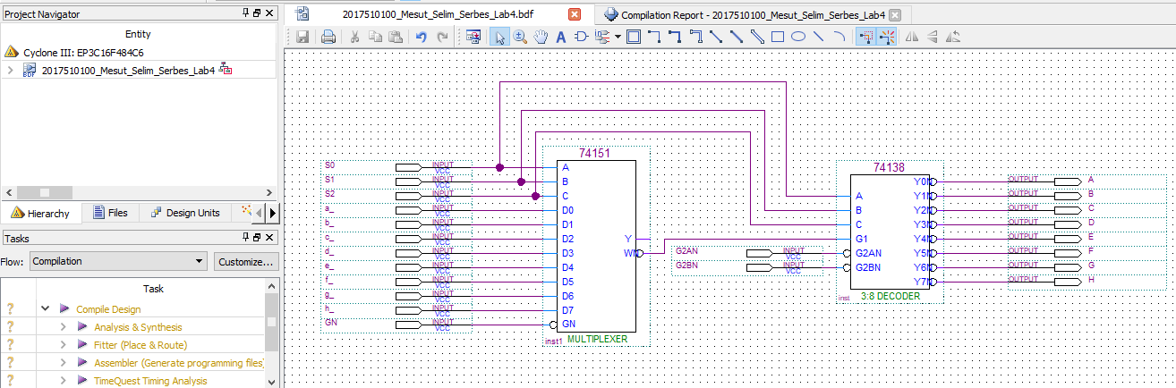**

**2.Experiment**

**a)**

**Divide-by-2**

**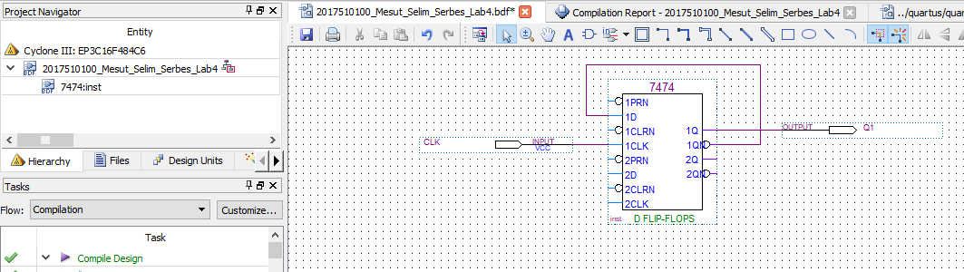**

**Divide-by-4**

**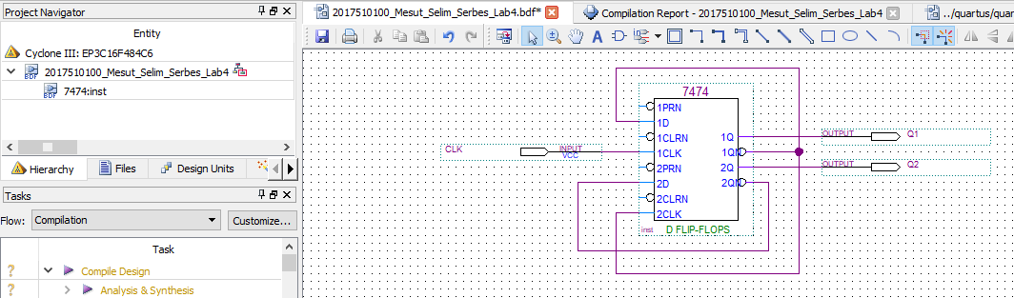**

**b-)**

**Divide-by-2**

**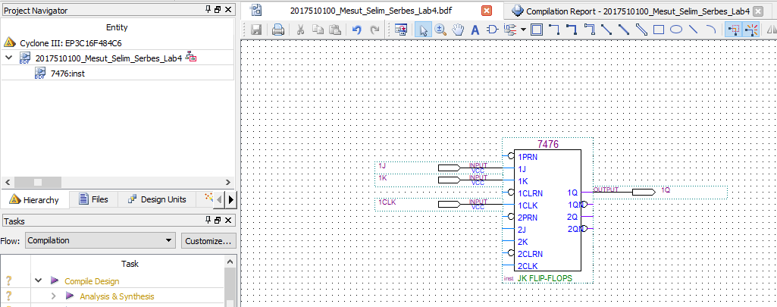**

**Divide-by-4**

**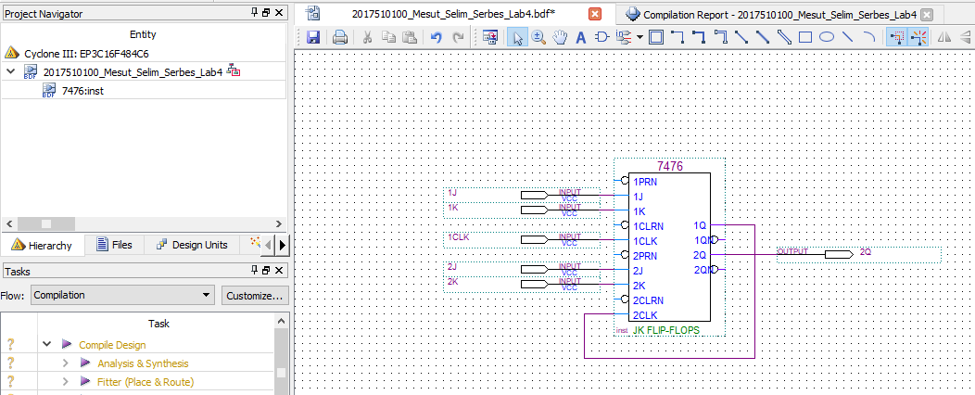**

* + - 1. **WAVEFORMS**

**1.Experiment**

**Functional Waveform**

**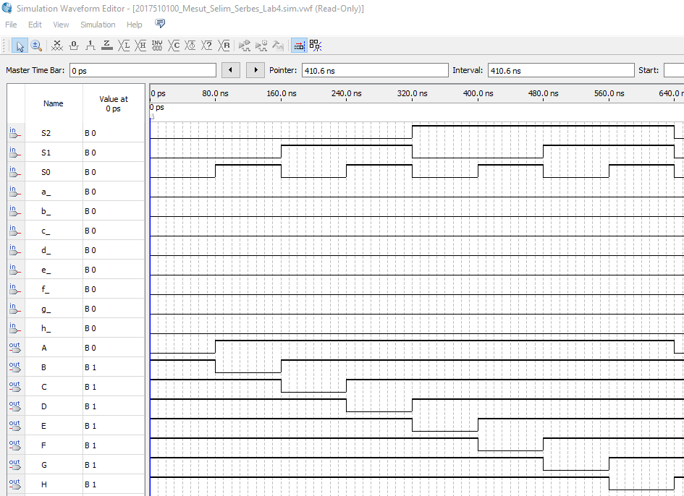**

**Timing Waveform**

**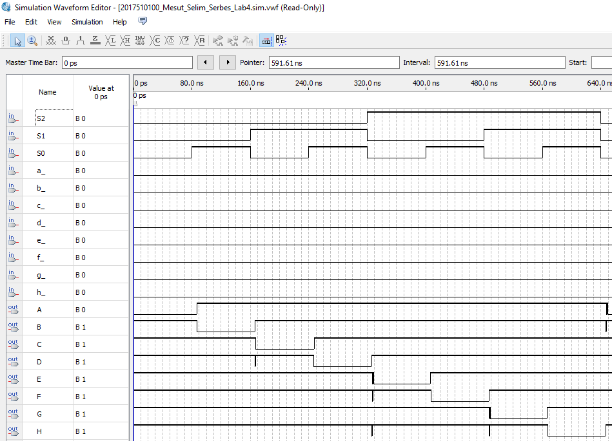**

**2.Experiment**

**a-)**

**Functional Waveform**

**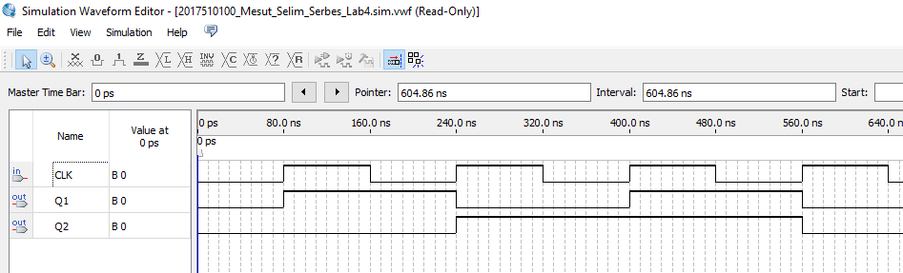**

**Timing Waveform**

**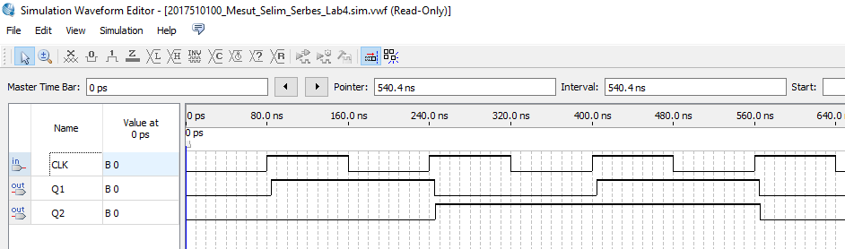**

**b-)**

**Functional Waveform**

**Divide-by-2**

**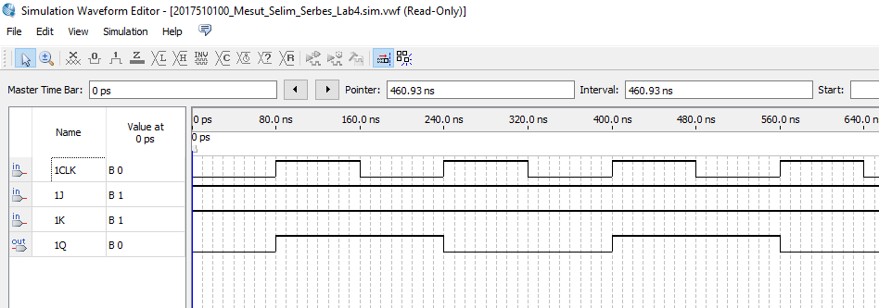**

**Divide-by-4**

**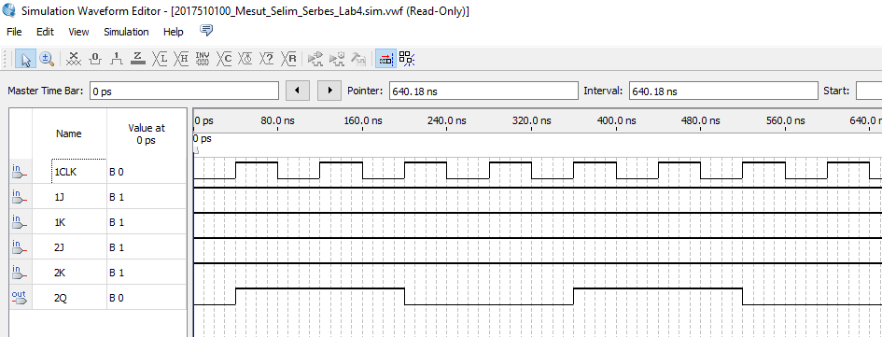**

**Timing Waveform**

**Divide-by-2**

**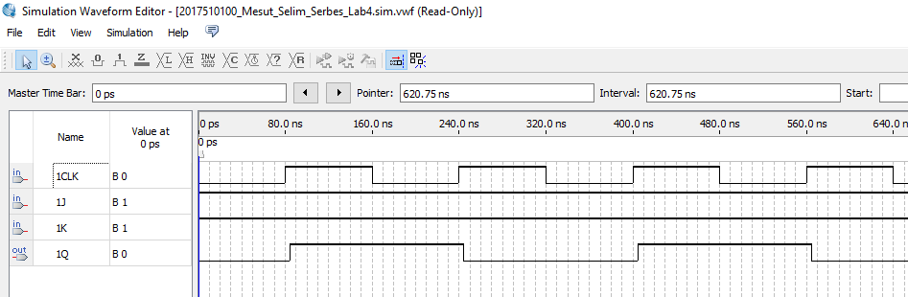**

**Divide-by-4**

**